Franklin County Sheriff’s Office
TIDSWELL, ERIC S

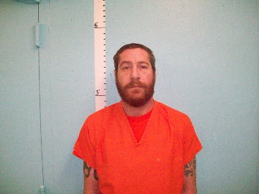
Arrived: 05/12/2019 @ 0834
Inmate ID: FCJ2508
Control #: 19FCS-339-JA
Sentence: Not Sentenced
Status: 05/12/2019 @ 0834 In Custody
Delivered: FCDC TRANSPORT
By Name: PHILLIP RICHARDS
Complex: Jail

Charges

Class D WRIT

Court:
Bail:
Bail Status: Unknown

Bail Summary For Court: : Outstanding

Vitals

Sex: M Race: W Age: 43 DOB: 03/15/1976
Home Address: PERU ME 04290

Height: 510 Weight: 193 Hair: BROWN
Eyes: BLUE Glasses Worn: N
Body: Complexion:

Military Active Duty: N
Foreign National: N

