Franklin County Sheriff’s Office
AMES, ROGER J

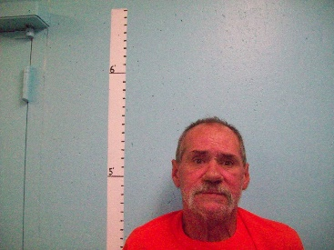
Arrived: 08/17/2019 @ 1207
Inmate ID: FCJ2761
Control #: 19FCS-582-JA
Sentence: Not Sentenced
Status: 08/17/2019 @ 1207 In Custody
Delivered: FRANKLIN COUNTY SHERIFF
By Name: DAVID DAVOL
Complex: Jail

Charges

9632 15 1092.1.A Class E VIOLATING CONDITION OF RELEASE

Court: Franklin Unified Court
Bail:
Bail Status: Unknown

Bail Summary For Court: Franklin Unified Court: Outstanding

Vitals

Sex: M Race: W Age: 56 DOB: 07/24/1963
Home Address: WELD ME 04285

Height: 508 Weight: 160 Hair: BROWN
Eyes: HAZEL Glasses Worn: N
Body: SLIM Complexion: FAIR

Military Active Duty: N
Foreign National: N

